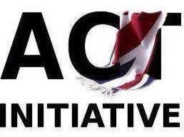

THE ACT INITIATIVE
178-180 Shankill Road, Belfast
BT13 2BH
Tel: 028 90 434827
Email:actinfo@yahoo.com
GROUP TOUR BOOKING

Reference

GROUP TOUR
BOOKING FORM

Customer Details
Organisation Name

Date

Contact

Address
Telephone

Tour Details Visit Type

Tour and Workshop
Date

Time of Visit

Group Size Others (Explain)

Extra Requirements:

Lunch £6 pp

Payment Details
THE ACT INITIATIVE
Name on the account:
90071749
Acc number:
95-01-45
Sort code:

Email

£200
Cost per group

Acceptance

I confirm that I have accepted on behalf of my group or organisation, the terms and conditions of The ACT Initiative. I accept the details above to be the booking I have made on the date and time as described in this document.

Sign Print Date:

Wheelchair access is available.
We are fully compliant with COVID-19 regulations.

